Leetcode question
Smallest Even Multiple - LeetCode
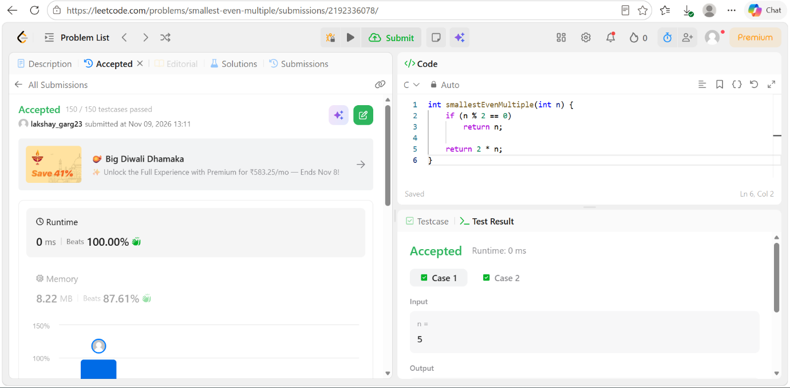

Code
int smallestEvenMultiple(int n) {
if (n % 2 == 0)
return n;

return 2 * n;
}

